2019 Heritage Middle Cross Country Summer Workouts
For all those interested in running Cross Country at Heritage Middle this fall, there will be summer conditioning workouts most every Tuesday and Thursday in the Chickamauga Battlefield. Attendance is not required to be on the team when school starts, but it is strongly encouraged and will certainly be beneficial in increasing your endurance and speed. It is also a great time to connect and build relationships with your teammates. Plus, every now and then there is watermelon and ice pops! All practices will begin at 6 p.m. at the Recreation field (see arrow on attached map). They will end at approximately 7:30. All students MUST HAVE A CURRENT PHYSICAL before doing anything with the team. This is not the only running you should be doing if you want to build up good endurance. Beginners, refer to the Summer Running Plan attached. If you are a returning runner you should already have a good idea of what you should be doing this summer. If not, ask Coach Crowder. Hydration is essential for these practices, and runners should hydrate throughout the entire day leading up to the practice. For any questions, please email dcrowder.hms@catoosa.k12.ga.us. Any other information will be shared through Remind. It is important to sign up in order to get information about practice. Text @hmsxc2019 to 81010.
Practice Schedule
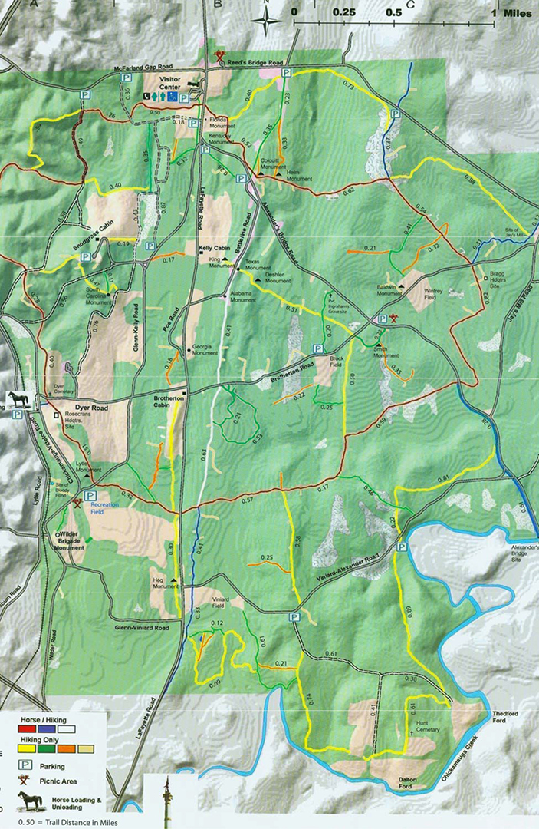
Tuesday 6/4 and Thursday 6/6
Tuesday 6/11 and Thursday 6/13
Tuesday 6/18 and Thursday 6/20
Tuesday 6/25 and Thursday 6/27
No practice the week of July 1st
Tuesday 7/9 and Thursday 7/11
Tuesday 7/16 (Work day @ HMS) and Thursday 7/18
Tuesday 7/23
Bryan Cross Country Camp Thurs.-Sun. 7/25-28
Tuesday 7/30
Thursday 8/1 End of the Summer Pizza Pool Party at Coach’s House! (Must have attended at least six summer practices. Parents encouraged to attend as well).
Beginning Runner Suggested Workout Plan
You should always be hydrated long before you attempt to do any workouts. It is also important to stretch before and after each workout. For these purposes a Fartlek means increasing your speed for one full minute every five minutes. XTrain refers to cross training such as biking, swimming, or some other form of aerobic exercise (high rep low weight lifting would work). If nothing else, a walk at twice the amount of time will be fine.
Week 1 | Sunday: OFF | Monday: 15 min | Tuesday:  15 min | Wednesday: OFF | Thursday:  XTrain 20 min | Friday: OFF | Saturday: 20 min
Week 2 | Sunday: OFF | Monday: 20 min | Tuesday: 20 min | Wednesday: OFF | Thursday:  XTrain 25 min | Friday: OFF | Saturday: 25 min
Week 3 | Sunday: OFF | Monday: 25 min | Tuesday:  20 min Fartlek | Wednesday: OFF | Thursday: XTrain 30 min | Friday: OFF | Saturday: 30 min
Week 4 | Sunday: OFF | Monday: 30 min | Tuesday: 25 min Fartlek | Wednesday: OFF | Thursday: XTrain 30 min | Friday: OFF | Saturday: 30 min
Week 5 | Sunday: OFF | Monday: 30 min | Tuesday: 30 min Fartlek | Wednesday: 30 min | Thursday: OFF | Friday: XTrain 40 min | Saturday: 35 min
Week 6 | Sunday: OFF | Monday: 35 min | Tuesday: 30 min Fartlek | Wednesday: 30 min | Thursday: OFF | Friday: XTrain 40 min | Saturday: 35 min
Week 7 | Sunday: OFF | Monday: 35 min | Tuesday: 35 min Fartlek | Wednesday: 35 min | Thursday: OFF | Friday: XTrain 40 min | Saturday: 40 min
Week 8 | Sunday: OFF | Monday: 40 min | Tuesday: 40 min Fartlek | Wednesday: 40 min | Thursday: OFF | Friday: XTrain 45 min | Saturday: 45 min

